Key points

2020 and 2021 are pandemic years. 2019 is the pre-pandemic comparator. Therefore, for this report we will focus on 2019 vs 2021.

FLS-DB key performance indicator (KPI)s
- Data completeness
- Identification of all fragility fractures
- Identification of spine fractures
- Time to FLS assessment
- Time to DXA
- Bone therapy recommended
- Falls assessment performed/ recommended / referred
- Strength and balance training non-hip # patients only
- Monitoring contact 12-16 weeks post fracture
- Commenced bone therapy by 16 weeks post fracture
- Adherent to a prescribed drug 12 months after fracture

Patient level data

- There are three time intervals of data to be analysed (2019 and 2021 in the main (KPI 1-10); 2019 and 2020 for KPI 11)
  - Interval a: Patients index fracture date from 1.1.2016 to 31.12.16
  - Interval b: Patients index fracture date from 1.1.2017 to 31.12.17
  - Interval c: Patients index fracture date in 1.1.2018 to 31.12.2018
  - Interval d: Patients index fracture date in 1.1.2019 to 31.12.2019
  - Interval e: Patients index fracture date in 1.1.2020 to 31.12.2020
  - interval f: Patients index fracture date in 1.1.2021 to 31.12.2021

- Key points to focus
  - Increased engagement with FLS community (number of participating FLSs f vs d
  - Number of records per site (interval d & f)
  - Changes in data completeness using KPI 1-10
    - Interval d vs f
  - Delivery of KPI 11
    - Interval d & e
  - Diversity and equity (given gender and age differences in fracture incidence and site do not include KPI 2 and 3) and test for significance for non-normal data
      - Men vs. Women for KPI 1,4,5,6,7,8,9,10,11
      - Age <75 years and ≥75 years for KPI 9
      - IMD ≤20% worst vs 80% highest IMD using postcode for KPI 1,2,3, 4,5,6,7,8,9,10,11
      - Analyse care home status by gender, age, admission to hospital and site of first fracture and KPI 4, 5, 6, 7, 8, 9, 10, 11

- Key data
- Number of FLSs submitting any data in 2021
- Number of FLSs actively participating > 50 patients in 2021
- Total number of patients per site in 2021
- For each KPI:
- National aggregate data - For all questions
- Between site data - For all questions
- For each KPI stacked bar chart for number of orange and green sites for intervals d and f Figure 2 of 2021 report e.g:
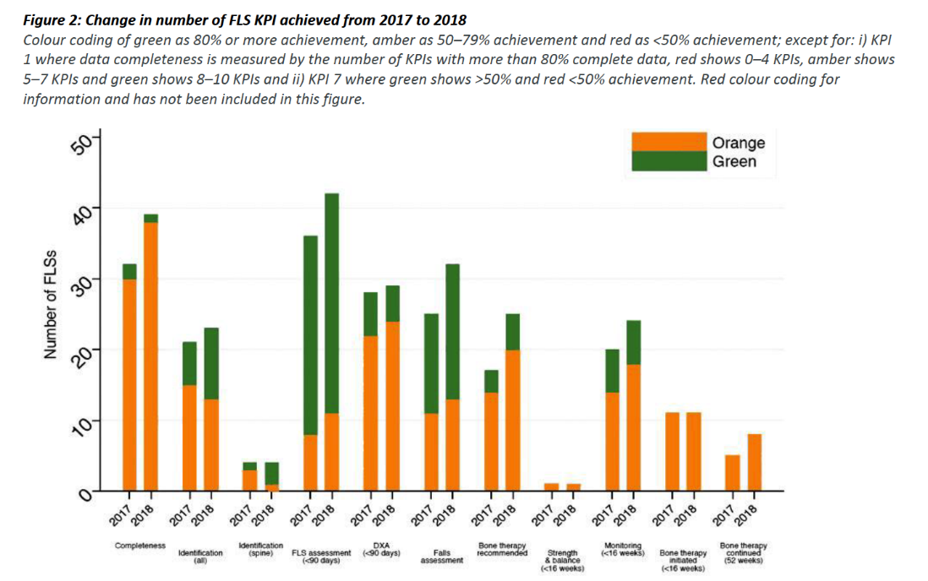

Data cleaning notes
- Remove FLS site = “YYY” – test FLS site
- Renaming FLS names
  - Any records for “RBE” sitecode were given the FLS name of “West Berkshire FLS”
  - Any records for “PET” sitecode were given the FLS name of “North West Anglia NHS Foundation”
  - Records for “NMH”, “RFH” or “BEM” were given the FLS name “Enfield Bone Health and Fracture Liaison”
  - Various FLS codes were inconsistent with codes using in the NHFD, so the following changes to FLS codes were made for sake of getting identification KPI:
  - AIR -> RCF; AHX -> SPG; BRH -> BRO; BWA -> AEI; ESH -> CGH; CHN -> UHN; HAY -> STO; LLD -> UHW; OIC -> OHM; SFL -> SHH; SRH -> SLF; WWL -> AEI

- Remove cases with ‘missing’ NHS number artemis code.
- For duplicates –
  - use the most recent complete record, i.e. combine duplicate records to use the most recent complete record that is not missing.
  - The exception to this is duplicate post code- use original post code
  - Flag if same artemis number, fracture date in more than one site. (e.g. Ealing / Northwick park, include FLS name and number of records
  - Re-fractures by interval plot with same artemis number and fracture site with difference in fracture date is less than 7 days, include FLS name and number of records
  - Flag if same artemis numbers but different fracture date (at least 7 days apart if same fracture site) to calculate number of re-fracture by FLS.
- Exclude FLSs with less than 50 cases in interval e= report them as stars
- Check for correct index fracture site order (hip is highest, then spine then non-hip / non-spine)
- Check for duplicates in linked NHFD sites
- Check for re-fractures in the same years as monitoring time points are fixed from first fracture of the year and not reset after a subsequent fracture in the same year.
Facilities audit data

Facilities audit data to inform clinical commentary (national figures) - percentage breakdown of the national sample for each response option eg 50/61 FLSs (82%) or average for the below questions:

- Question 1.1
- Question 1.4 (by year)
- Question 1.5
- Question 1.6 (average)
- Question 1.7 (average WTE nurses and administrators only)
- Question 1.8
- Question 2.1 (average)
- Question 2.2
- Question 2.3
- Question 2.3.1
- Question 3.1
- Question 3.2
- Question 3.3
- Question 3.4
- Question 3.5
- Question 3.6
- Question 4.1
- Question 4.2
- Question 5.1
- Question 5.2
- Question 5.3
- Question 6.1
- Question 6.2
- Question 6.2.1
- Question 7.1
- Question 7.2
- Question 8.1
- Question 8.2
- Question 8.3
- Question 9.1
- Question 9.2
- Question 9.3
- Question 9.4
- Question 10.1
- Question 10.2
- Question 10.3
- Question 11

Indicator | Numerator | Denominator | Comment
- Data completeness | Number of Key performance indicators 2-11 with more than 80% patients completeness | 10 (KPI 2-11) | 1. Calculate for interval d and f  - Missingness in KPI 2 describes missingness in fracture type in original data (after that, where type of fracture was missing, fragility was assumed).  - For completeness stats of KPI 8 & 10, excluding any records not followed-up at 12-16 weeks  - For completeness stats of KPI 11 excluding records not followed-up at 48-52 weeks  - National average
- Identification | Total number of patients with fragility fracture submitted | Estimated fragility fracture caseload using annualised data from National Hip Fracture database (NHFD) x5 for that year. | 1. For interval d and f overall change in KPI:  a) average number of patients per FLS  b) average percentage of estimated caseload  - For interval f: by site, Table 4:  - Numerator is number submitted from FLSDB  - Denominator per site is number of hip fractures submitted to NHFD in 2021 x5.  - Estimated caseload  - Percentage of estimated caseload submitted (all, <75 & >75yr)  - Plot figure. X axis is sorted by FLS volume in decreasing order. Y1 is total number cases submitted with black circle marker. Y2 is the proportion of first fractures divided into hip, non-hip, non spine, spine and missing as a stacked bar chart. See sample below  - 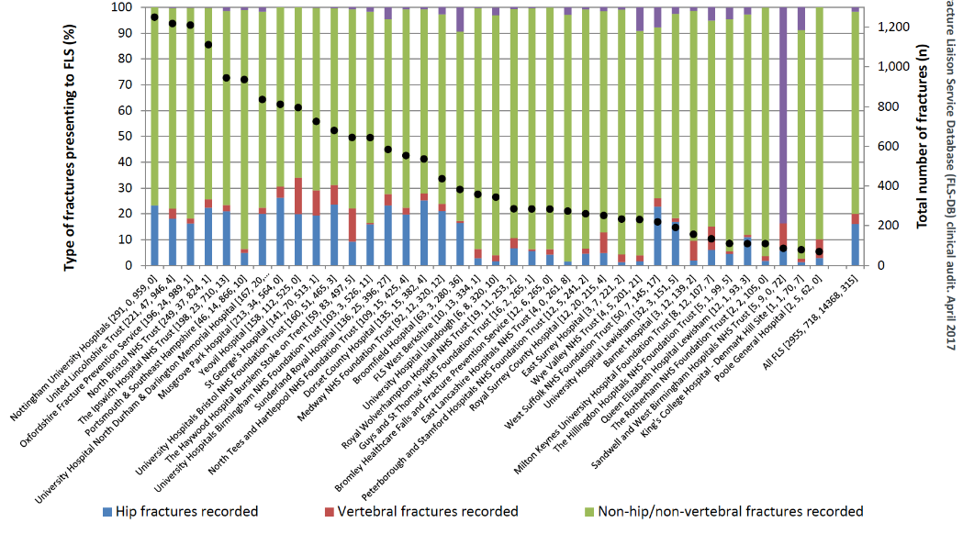  - total number of hip cases and % of hip cases compared with total number of cases submitted: (Table 4)  - National average
- Spine fractures identified | Number of patients submitted with a spine fracture as primary fracture site | Number of Hip fractures using annualised data from National Hip Fracture database (NHFD) for that year | 1. Will include both clinical and radiological spine fractures  2. Table 1: Interval d vs f; by FLS  - Percentage of spine/ hip fractures submitted  - National average
- Time to bone health assessment within 90 days | Number of patients with date of fracture – date of assessment = 90 days or less | Total number of patients submitted | 1.For interval d vs f: by FLS  - number submitted  - number assessed within 90 days  - % assessed within 90 days. (Table 5)  2. Need to table by FLS where the data of assessment is missing  - Ratio of number of patients who Did Not Attend / total number of patients submitted by FLS for interval f  - National average
- Time to DXA within 90 days | Number of patients with Date of DXA - Date of fracture = 90 days or less | Total number of patients submitted minus a) number where DXA already done; where a DXA was not ordered or where DXA status was missing | 1.For interval d vs f: by FLS  - number DXA recommended or ordered  - number date of DXA within 90 days  - % within 90 days. (Table 6)  - Did not attend  - For all patients combined and stratified by age < 75 years vs 75 years+  - National average
- Falls assessment | Number of patients with a falls assessment performed, recommended, referred for or already under falls service | Total number of patients submitted | 1.For interval d vs f: by FLS: table 7:  - Facilities question 6.1. How many perform a falls assessment  - number and percentage for all patients / number submitted total all ages and stratified by age < 75 years vs 75 years+  - National average
- Bone therapy recommended as appropriate | Number of patients with a treatment recommendation as specific bone therapy, refer for further clinical opinion, refer to GP to decide | Total number of patients submitted | 1. for interval d vs f by FLS table 8 for all ages and add column for missing (for all)  2. Subgroup of treatment options:  - OralBP (alendronate , risedronte, ibandronate)  - Denosumab  - Zolendronate  - Raloxifene  - Teriparatide  - Referred to GP to decide prescription (called “referGP” in Excels)  - Referred for further clinical opinion (called “refer_opinion” in Excels)  2. for interval f, by FLS, table 9 for all subgroup by type of therapy, n & %.  If more than 1 drug submitted use this hierarchy: oral bisphosphonate > denosumab > zoledronate > > raloxifene > teriparatide > referGP, Refer_opinion  - National average
- Strength and balance commenced | Number of non-hip non spine and spine fracture patients initiating a strength and balance class within 16 weeks of date of fracture | Number of patients with a bone therapy treatment recommendation or referred to GP or referred to other clinician minus patient dead where the fracture site is non-hip non-spine, spine | 1. For interval d vs f, by FLS for all ages and stratified by age < 75 years vs 75 years+  2. National average
- Recorded Follow-up 12 – 16 weeks post index fracture | Number of patients followed up post fracture = yes | Number of patients with a bone therapy treatment recommendation or referred to GP or referred to other clinician minus (patient dead and patient declined) | 1. for interval d vs f: columns for all fractures hip fracture vs. non-hip fracture, number eligible for monitoring all, hip, non-hip and then percentage monitored with FLS as rows (table 10)  2. Does not include calcium / Vitamin D only  3. National average
- Commenced bone therapy at 16 weeks | Number of patients commenced or continuing bone specific therapy within 16 weeks of date of fracture | Number of patients with a treatment recommendation or referred to GP or referred to other clinician minus (patient recorded as died and patient declined) | 1. for interval d vs f, by FLS n and %  2. National average  n.b. answers for 6.05 and 7.05 changed in 2020 to include treatment names from “Started recommended bone therapy” and “Switched recommended bone therapy”
- Did the patient confirm adherence to prescribed bone sparing drug at 12 months? | Number of patients continued taking recommended drug or switched drug at 12 months post fracture | Number of patients with a treatment recommendation or referred to GP or referred to another clinician minus (patient died and patient declined) | 1. for interval d vs f by FLS.  2. include non-contactable in the denominator  3. National average  n.b. answers for 6.05 and 7.05 changed in 2020 to include treatment names from “Started recommended bone therapy” and “Switched recommended bone therapy”

