

Contents

Introduction 3
Introduction to quality improvement 4
Step 1: Identify everyone’s role and influence in the team and wider stakeholders 5
Step 2: Measuring your current pathway 8
Step 3: Prioritise the gaps 9
Step 4: SMART aims 11
Step 5: Understanding the causes of the gaps in performance 13
Step 6: Designing the service change 18
Step 7: Review and plan 20
Step 8: Sustain and spread – embedding change 21
Step 9: Evaluating your improvement project 22
Step 10: Sharing your journey and learning 24
Step 11: Feedback 25

Introduction
The Falls and Fragility Fracture Audit Programme (FFFAP) is a national clinical audit run by the Royal College of Physicians (RCP), designed to audit the care that patients with fragility fractures and inpatient falls receive in hospital and to facilitate quality improvement initiatives. The programme is commissioned by the Healthcare Quality Improvement Partnership (HQIP). FFFAP is comprised of three audits:
- National Hip Fracture Database (NHFD) - the audit collects data on all patients admitted to hospital with hip fractures.
- Fracture Liaison Service Database (FLS-DB) - evaluates patterns of assessment and treatment for osteoporosis and falls across primary and secondary care.
- National Audit of Inpatient fall (NAIF) – audit evaluates both fall prevention prior to the hip fracture and post falls care.

We all want to do better for our service and for our patients. However, in this era of ever-increasing financial restraints and other competing healthcare conditions, we are often in a position where we must improve our service on a budget using whatever resources are available to us at that moment.

We hope that this workbook will help to teach you techniques that you can use during your work practice to continually improve over time in spite of the challenges we face today.
The techniques are based on the Institute for Healthcare Improvement (IHI) breakthrough collaborative series model, which has achieved dramatic results, including reducing waiting times by 50%, reducing ICU costs by 25%, and reducing hospitalisations for patients with congestive heart failure by 50%; all without substantially increasing resource use.

The key to this is becoming more effective and efficient at service delivery by identifying gaps in our service and brainstorming techniques for improvement.

To help with patient and public involvement at a site/trust/health board level, FFFAP’s Patient and Carer Panel has co-created a guide to patient and carer involvement. Having the help of a person who has experienced the service to guide you through from their perspective can be invaluable and transform the way your service engages with those for whom you care.

At the centre of any improvement work should be the data that you are measuring the change through. To check your data, please visit the Falls and Fragility Audit Programme.

Introduction to quality
improvement
Quality improvement (QI) is defined as the continual actions to improve outcomes for service users and to develop the workforce that supports them using systematic methods.
This involves seven steps as illustrated below:
Becoming more effective

QI may seem daunting; however, if we break down the process into easily attainable steps it will lead to an achievable and workable plan.

Please take the time to complete each exercise in the workbook with your team rather than just reading through it. There is something transformative about taking your invaluable thoughts and organising these on paper.

One of the key concepts we want to emphasise is the importance of tracking your work, including what you do and your outcomes. This will help you see if your change is making an impact.

Remember: what gets measured, gets managed.

Step 1: Identify everyone’s role
and influence in the team and
wider stakeholders
Your improvement team and stakeholder engagement

Aim: to identify, map and allocate roles to your core improvement team and be aware of wider team members who you will need to keep informed about the progress of your project.

The reality is everyone has a role in your team, but members have different skills, influence, interest, time, roles and seniority within the organisation. Therefore, some team members are more ideally placed to help you achieve your goals. Having an in-depth knowledge of this is important when you plan your project.

It is important to remember that patients and carers are an integral part of your team as they have a unique perspective on informing you how your service runs and where the gaps are. They will help to build the collective intelligence of your group and give you a wider range of solutions from which to choose. They should therefore be a part of brainstorming sessions to help you decide which quality improvement project in your service needs to be prioritised.

- Map all the people involved in the care pathway from the provider and patient perspective.
- Think about the processes of care involved in your focus for improvement. What departments/teams are involved?
- Consider who contributes to the service and what they contribute, who benefits from the processes and what specific benefits they receive. Finally, consider who else (internal and external to your organisation) is involved and invested in this project.
- Consider an interprofessional approach.
- Include people with the influence to support any service changes you may propose.
- Include at least two patients/carers in your team. To help with patient and public involvement at a site/trust/health board level, FFFAP’s Patient and Carer Panel has co-created a guide to patient and carer involvement.
- The empowerment and influence lists below provide areas to consider when involving people in your team. The stakeholder map provides a tool to think about levels of engagement versus levels of influence, to map team members and stakeholders.

Worksheet – Empowerment and influence
Empowerment and influence |  | Stakeholder map
1 | Lead | High  High  Low  Engagement  Engagement  Influence  Influence  Key stakeholders  Low
2 | Multidisciplinary
3 | Range of seniority
4 | Patient / carer
5 | Time to deliver
6 | Able to deliver

Take the time to fill in this worksheet with the members of your team, with comments on who would be most suitably placed (due to the various factors described above) to help you achieve your project goals.

Role | Name | Core team (y/n) | Comment
Lead
Patient
Map the other stakeholders who you have identified in the exercise above into each of the sections below, based on the impact/influence that they will have on your project:

Satisfy  Opinion formers. Keep them satisfied with what is happening and review your analysis of their position regularly. | Manage  Key stakeholders who should be fully engaged through full communication and consultation.
Monitor  Interactions with this group may be paused if time and resources are stretched. | Inform  Patients often fall into this category.  It may be helpful to take steps to increase their influence by organising them into groups or taking active consultative work (see below).

Co-production with patients and carers
Have a look at the different levels of involvement described in the table below. As a team, discuss which you think you do already? What more would you like to do?

Information | Consultation | Involvement | Co-production
Patients and carers given information about plans and changes via meetings, leaflets etc. | Views of patients and carers sought via surveys, feedback, focus groups etc. | Patients and carers influence governance and policy development | Genuine partnership with agreed principles for working
No requirement to act on feedback from patients and carers | Data gathering from these used to support decisions made by clinical and managerial staff | Individual patient and carer perspectives seen as integral | Agreed shared agenda
Quality measures use clinical guidance and standards only | Quality measures informed by feedback from consultations | Some projects/initiatives led by patients and carers | Partnership approach to quality measures using representative patient and carer experience as a driver
Vision and leadership and setting of agenda all set by staff | Vision and leadership informed by feedback from patients and carers | Organisation is responsive to patient and carer involvement but not as equal partners | Leadership and vision owned by all

Step 2: Measuring your current pathway
Now that we have an idea of who in the team you would focus on, it is now time to see which areas of your service delivery or key performance indicators (KPIs) you need to focus on. Below are the KPIs of the three workstreams in FFFAP (NAIF, NHFD, FLS-DB) – please select the workstream to focus on and complete the respective worksheet.

NAIF worksheet – Current service performance
Check your service against the NAIF KPIs and complete the table below:
NAIF KPIs | Performance
Participation
Participation in the audit
Post-fall management
Check for injury before movement from the floor
Safe manual handling methods used
Medical assessment within 30 minutes
Multifactorial risk assessment
Assessment of vision
Assessment of lying/ standing blood pressure
Evidence of medication review
Delirium assessment and care plan
(if indicated)
Mobility assessment and plan (if indicated)
Continence assessment and plan (if indicated)

NHFD worksheet – Current service performance
Check your service against the NHFD KPIs and complete the table below:
NHFD KPIs | Performance
Admission to specialist ward
Prompt orthogeriatric review
Prompt surgery
NICE compliant surgery
Promptly out of bed
Not delirious post-op
Return to original residence
Bone medication

FLS-DB worksheet – Current service performance
Check your service against the FLS-DB KPIs and complete the table below:
FLS-DB KPIs | Performance
Non-spine case identification
Spin fractures
Assessment within 90 days
DXA within 90 days
Falls risk assessment
Bone treatment
Strength and balance by 16 weeks
16-week follow-up
Treatment by 1st follow-up
1-year drug adherence

Step 3: Prioritise the gaps
Choose one area of improvement that will positively
affect your service the most

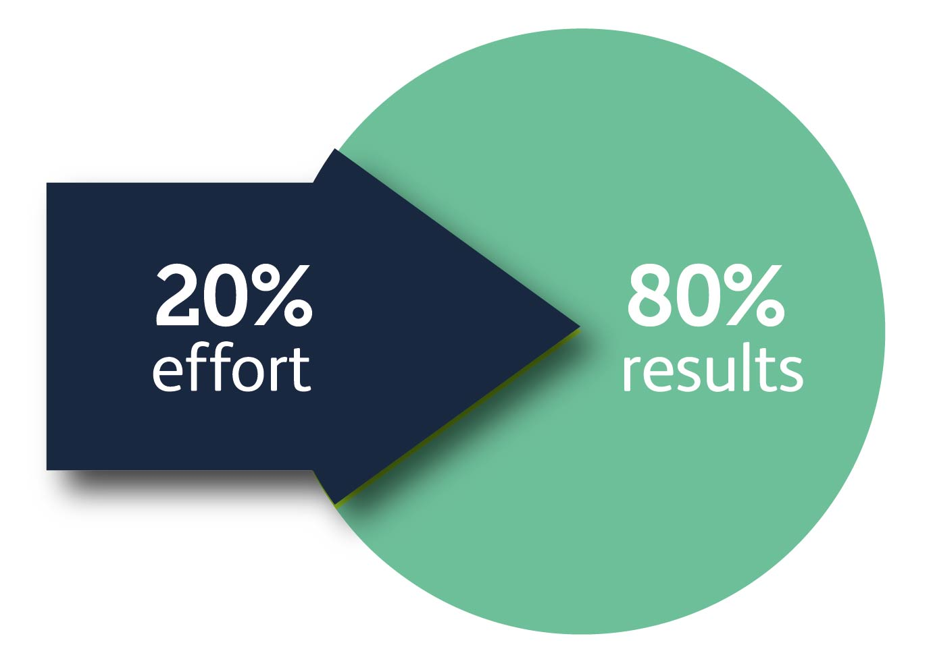
The next step is choosing a project that will give you the most benefit using the least effort. This is sometimes referred to as Pareto’s principle. Here is a link to another resource: IHI Open School resources

Worksheet – Potential areas for service improvement
Use this worksheet to grade how beneficial an improvement would be to patients when you compare different domains of care. Don’t worry about getting it exactly right – put the first number that comes to your mind.

Care pathway component from KPIs | How much benefit?  (low, med, high) | How much effort?  (low, med, high)
Eg post-fall management | - High: Patient care  improved with better outcomes from fall.  - Less potential harm to patient as moved correctly.  - Hip fracture identified sooner to allow optimal hip fracture management in terms of time to surgery.  - Reduced length of stay. | - High: Lack of available equipment.  - Reduced staffing to allow for a prompter assessment.

Congratulations on reaching the end of this worksheet, you now have a visual representation
of which parts of your service would benefit with the least amount of effort. This is unique to your service and is something on which only you have specific knowledge.
If your colleagues have filled in the sheet with you, compare your results after you have
completed your worksheet.
1= Low benefit

2= Moderate benefit

3= High benefit

a= Low effort

b= Moderate effort

c= High effort

Step 4: SMART aims
It is important to align your improvement project aim with the values or vision of your organisation. Write this down below:

Organisation vision/values:

Now that you know which KPI that you would like to focus on, the next step would be to structure your goal in the form of a SMART AIM:

S | Specific | a precise outcome
M | Measurable | a defined element to demonstrate the outcome
A | Achievable | realistic given the constraints of time and resources
R | Relevant | directly linked to a goal
T | Timely | includes when outcomes would be achieved

Take your time in filling out your SMART aims as this will be the vision for your goal. In line with what we have discussed so far, the outcome should be measurable. Use simple language, action words and numbers in your SMART aim. Learn more about SMART aims: www.youtube.com/watch?v=1-SvuFIQjK8

Worksheet – Describe your SMART AIM
Define your aim (make sure this is SMART and easy to understand for someone outside your team):

 | Example | Priority 1 | Priority 2
Specific outcome / KPI | Aim to increase attendance at clinic X
Defined measurement of outcome | By 50%, from 10 to 15 patients per month
Achievable | By increasing our telephone clinic capacity
Relevant | Through developing an online training platform
Timely | In 6 months – by December 2023
Other comments

How will this be measured?
It is important to think about how you will measure the impact of your proposed service change. The key measure is the outcome measure – a change in patient outcomes. Sometimes there is also a process measure that is required to reach the outcome.

Also remember that when there is a focus of energy and resources into a goal, previous gains in other areas may be lost. For example, focusing on one part of the pathway may lead to less time for other parts and some KPIs could get worse. Therefore, it is important to make a note of which KPIs are more likely to be affected and use these as balancing measures to ensure that this does not happen.

Measures that should improve:
- Outcome measures
- Process measures

Measures that should be maintained:
- Balancing measures

Worksheet – Describe the measures for your SMART aim
Please complete the table below with this information to identify the outcome, process and balancing measures to consider:

KPI | Target to improve | Balancing measure to maintain
eg post-fall management | To increase the number of documented assessments for injury post falls (audit and input into individual run chart)  To increase the number of documented safe lifting methods post-fall (audit and input into individual run chart) | Other ward incidents not increasing due to more focus on falls management.

You can then describe each measure in more detail:
Measure
What is it that you want to measure?
Type of measure
Outcome, process, balancing, qualitative – which one is it?
Definition
Concept
Why measure it?
Denominator
Sample
Are you collecting on all occurrences?
Frequency
How often will the data be collected?
Data collection
How will the data be collected?
Person responsible

Step 5: Understanding the causes
of the gaps in performance

In order to get an in-depth understanding of why you were getting the previous results, we need to repeatedly ask why until we get to the root cause. Many reasons can lead to the same outcome, so it is important to look for reasons why the service is not getting the desired results.

Below is an example of a fishbone diagram looking for the reasons why patients sometimes have a fall when they are transported within the hospital.
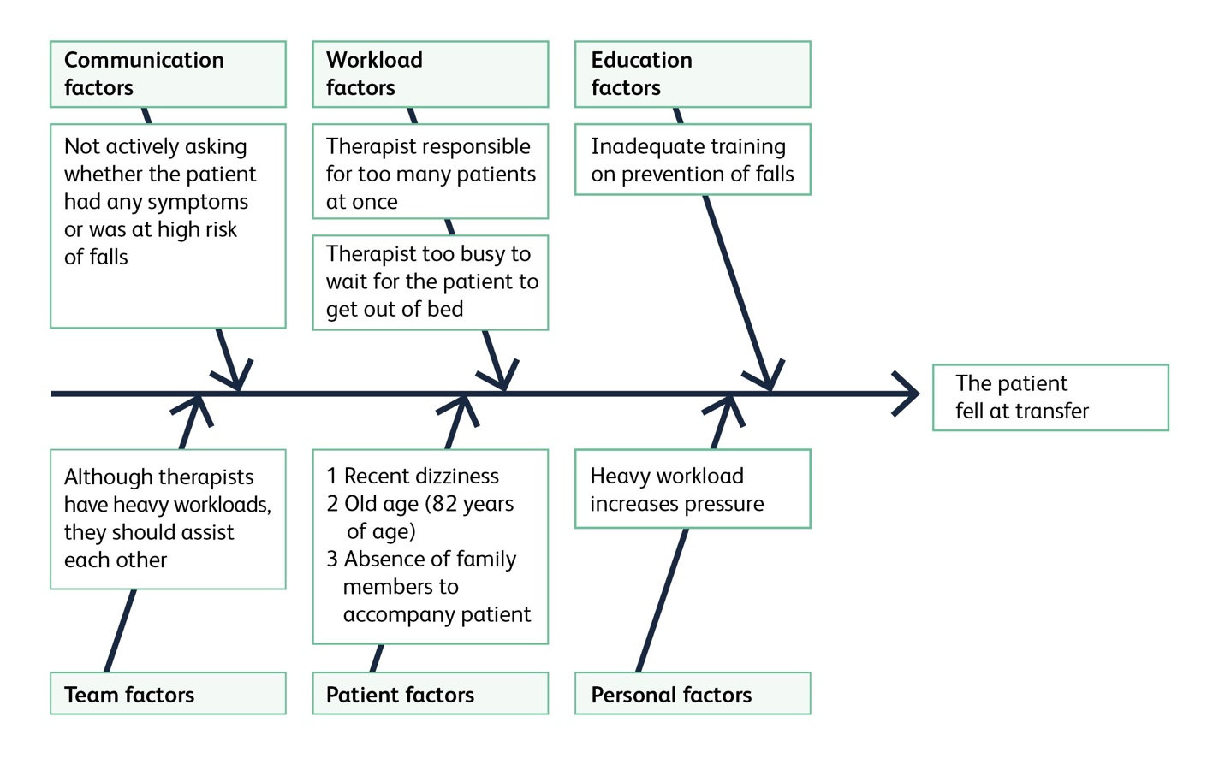
For your SMART aim you can adapt the number of categories. A key category to consider using is ‘organisational/management’ as this is often critical for achieving sustainable change.

Worksheet – Describe the causes for the underperformance
of your priority area for change

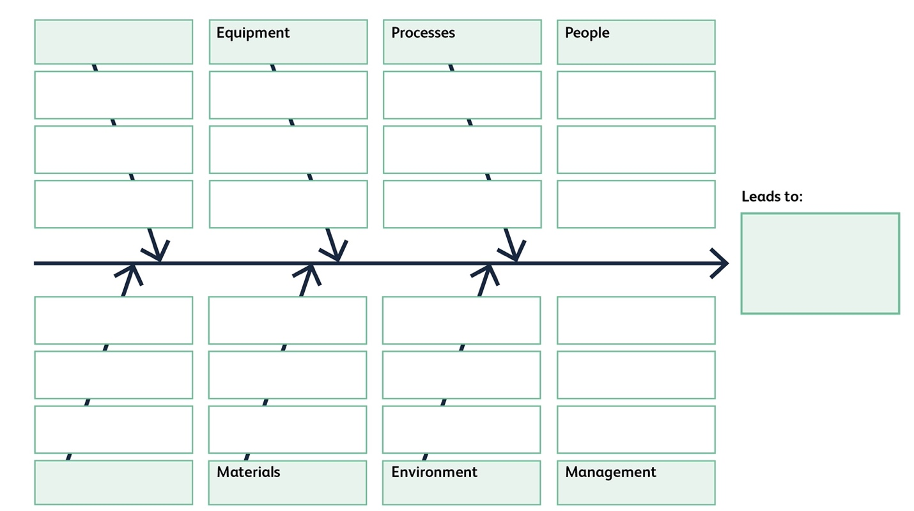
Use the example above to work out the possible causes of underperformance relating to your chosen KPI in your service:

Change idea generation – introducing driver diagrams
Another way of describing why an event may happen is by using driver diagrams to get to the root cause. This simply involves asking why a certain event has happened and questioning the reasons given to get to the cause. You can then use this to develop your change ideas. Learn more about driver diagrams: www.youtube.com/watch?v=A2491BJcyXA

Please find below a worked through example of a driver diagram. On the next page you have a blank template to complete for your quality improvement aim. You can have more than one secondary driver for a primary driver, and one secondary driver can be linked to more than one primary driver.

Aim | Primary driver  What big statements/ needs will support your aim? | Secondary driver  What needs to happen to tackle  or support the cause to get you towards your aim? | Change ideas  What are your ideas / test cycles that will support your secondary drivers and move you towards your aim?
Monitoring contact 12–16 weeks post fracture | Assessments not completed by patient | Patients don’t value importance of monitoring.  Too hard for patients to complete monitoring.  Monitoring method not tailored to a patient’s preferred method. | Highlight monitoring during initiation visit.  Ask patients to review the questions.  Offer letter, telephone, SMS and email.
Monitoring contact 12–16 weeks post fracture | Assessment not completed by care home staff | Care home staff don’t appreciate urgency of starting therapy.  Care home staff are not trained to complete monitoring. | Produce a 1-page guide.  Create flow chart.
Monitoring contact 12–16 weeks post fracture | Assessment returned late | Timing of monitoring too late to allow repeat calls.  No reminder pathway. | Send monitoring 6 weeks early.  Create a query to find non-responders after 4 weeks and send a reminder.

Worksheet – Describing your drivers and potential change
ideas

Use the example above to work out the possible causes and potential change ideas.

Aim | Primary driver  What big statements/ needs will support your aim? | Secondary driver  What needs to happen to tackle  or support the cause to get you towards your aim? | Change ideas  What are your ideas / test cycles that will support your secondary drivers and move you towards your aim?

Step 6: Designing the service change
Worksheet – Prioritise your service change ideas
The next step is to formally design your service change.

- First you need to prioritise each potential service change idea by thinking about:
- Is it service change (that can be done within existing resources/staffing) or service development (that requires additional investment/resources/staffing)?
- How easy is it to implement?
- How impactful will it be?
- How desirable is the change?
- What assumptions need to be tested?
- What happens if your change idea fails?

Use the table below to choose the top one or two ideas to take forward.

 |  | Idea 1 | Idea 2
Summary | Title of change idea
Is this service improvement? | A change that can be done within existing staffing/resources
Or is this service development? | A change that needs more staffing/resources?
How easy is it to implement? | Easy, medium, hard
How impactful will it be on patient outcomes? | Small, medium, large
How desirable is the change by the service? | Not, medium, highly
What assumptions need to be tested?
What happens if the change fails?

- When you have selected your change idea, there are two more steps to think about in terms of increasing sustainability:

- How can you make your change idea more sustainable?
- Discuss with the team the different options for making the service change have a greater impact/benefit.
- Discuss with the team the different options for making the service change have a lower demand on staff, motivation and costs.

- Smallest scalable unit?
- Discuss with your team what is the smallest part of the pathway on which you can first test your service change. This could be a certain type of patient by age, location, team member or day of the week. The idea is to test the service change in the smallest scalable unit; learn from it, modify the service change and then scale it up to the next level, eg other patient groups/locations/days of the week.

Worksheet – Describing your service change ideas

- Describe the service change in detail:

Key driver
Change idea / pathway change
Opportunities for implementation
Challenges for implementation
Expected impact
Expected desirability
Outcome measures and timing
Process measures and timing
Balancing measures and timing
Sustainability
Smallest scalable unit
Scaling up plant
Other assumptions
Who needs to know about the planned service change
Timing for outcomes measurement

Step 7: Review and plan
Review your results and plan the next cycle
Finally, you need to evaluate your work to see if you have set out to make the change you had planned. This should be done using the outcome measures in the SMART aims. If you have been successful, this is excellent, you can now plan another QI cycle to build on your success and get even better. You have successfully completed what is called a Plan-Do-Study-Act or PDSA cycle and a series of such cycles will get your FLS to perform effectively, more efficiently and with greater patient satisfaction over time.

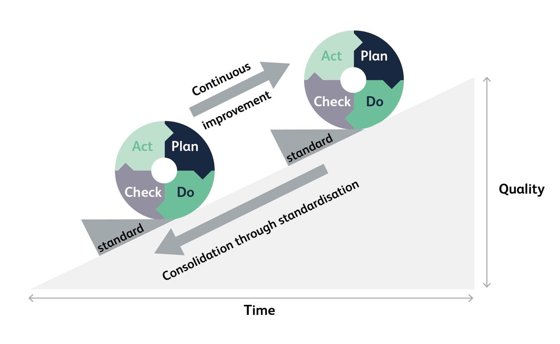
Learn more about the PDSA: www.youtube.com/watch?v=szLduqP7u-k

Step 8: Sustain and spread – embedding change
Almost there…
Once you have completed your local service change, start thinking about how to sustain the change locally and then what you can share with other sites and how to do it. With your team, complete the sustain and spread plan below to consider which factors of your improvement project you will need to sustain, and what you could spread to create more improvements elsewhere in your service/ organisation. You may want to identify parts of the service change that should stay constant and parts that need to adapt when applied to local hospitals.

 | Team | Stakeholders | What? | How? | Who will lead this?
Sustain
Spread

Step 9: Evaluating your
improvement project
Now is the time to step back and review your team’s service change at different levels.

What are your successes?

Who? | Outcomes | Processes | Measures | Stories/relationships
Patient
Staff

Organisation

Also think about:

Understanding and overcoming barriers to change
Reflect on barriers you have come up against in this project and how you have overcome them.

Forces for change | Forces against change

What factors were important in your success?

What would you do differently?

Consider building in a narrative to share how your project has progressed. You may wish to create a storyboard that can be shared within your service or start to write a paper/create a poster for publishing in journals and conferences.

Step 10: Sharing your journey
and learning
We would encourage you to use the FFFAP case study template to publicise your findings on the FFFAP improvement repository.

Create a poster, journal article or storyboard to share – who is your audience?

SQUIRE 2.0 has some useful guidelines on how to write up your quality improvement work,
should you want some additional support:
http://squire-statement.org/index.cfm?fuseaction=Page.ViewPage&PageID=471

Team
Project
Aim
Project team involved / time period
Why did you want to do this project? (drivers for change)
Describe your progress so far or the project outcomes that have been achieved.
Successes
Challenges
Lessons learnt
Additional or continuing work
On reflection, how do you think the project has benefited the care you provide to your patients?

How has your team worked?

How did the patient working in the team contribute?

What about the workbook did you find most useful?

Next steps?

Step 11: Feedback
We do hope that you have found using this workbook helpful. We encourage you to give us any feedback so that we may improve it going forward. Please send any comments to fffap@rcp.ac.uk.

‘What gets measured gets managed’
Peter Drucker, author and influential thinker on management



